**Web Programming**

**Btech SEM:V (20-21)**

**Program 2**

**PART-A**

**A.1 Aim:**

Create a static web pages using HTML

1. Use attributes link, alink and vlink for text hyperlinks created in program 1
2. Also use target attribute for the link (use values: self, blank)
3. Create link to section within same page
4. Make image as a hyperlink in program 1
5. In the table created in program 1, use attributes colspan, rowspan, cellspacing, cellpadding and caption tag
6. Use attribute type for lists in program 1 to change the type of sequence numbering
7. Registration page (Use form tag)
8. One web page with frames implemented

**A.2 Prerequisite:**

There are no prerequisites as such to learn and implement HTML.

**A.3 Outcome:**

After successful completion of this experiment students will be able to

1. Understand the basic Technique in building a static web application using HTML

2. Implement basic tags of HTML with attributes

3. Understand usage of basic editor like Sublime Text 2 or 3

**A.4 Theory:**

* link,alink,vlink: are attributes to give colours to link,active link, visited link

EX: <a href = "reg.html" alink=”red” vlink=”green” link=”black” >registration</a>

* target attribute is used to specify the location where linked document is opened

_blank : Opens the linked document in a new window or tab.

_self: Opens the linked document in the same frame.

* Linking to a Page Section

First create a link to the place where you want to reach with-in a webpage and name it using <a...> tag as follows −

<p>This is first section <a **name** = "top"></a><p>

Second step is to create a hyperlink to link the document and place where you want to reach −

<a href = "#top">Go to the Top</a>

* **Form tag:**

The following code creates a form with first name field

<html>

<head>

<title>Text Input Control</title>

</head>

<body>

<form>

First name: <input type = "text" name = "first_name" />

</form>

</body>

</html>

Form action and method attributes need not be used.

1. Create one text field for username (input type=”text”)
2. Create one password field (input type = "password")
3. Create one email field (input type = "email")
4. Create three checkboxes and by default the first one needs to be checked

<input type = "checkbox" name = "OOPS" value = "Subject"> OOPS

<input type = "checkbox" name = "C" value = "Subject"> C

1. Create two radio buttons
2. Create a dropdown list with 5 items and by default the first item needs to be chosen

<select name = "dropdown">

<option value = "OOPS" >OOPS</option>

<option value = "C">C</option>

</select>

1. Create a text area (<textarea rows = "5" cols = "50" name = "About Yourself">)
2. Create one submit and one reset button

<input type = "submit" name = "submit" value = "Submit" />

<input type = "reset" name = "reset" value = "Reset" />

1. Make image as button

**Frames**

Look at the following code:

<frameset rows = "60%,40%">

<frame name = "top" src = "home.html" />

<frame name = "bottom" src = “registration.html" />

<noframes>

<body>Your browser does not support frames.</body>

</noframes>

</frameset>

* Use frameset tage instead of body tag.
* The above code divides browser window into two rows.
* In each row we can see the corresponding html page
* The same is to be done with columns too( use cols=” ”)
* noframes will be interpreted by the browser if browser does not support frames

**Note: It is left to discretion of students to decide the topic to make static webpages on. Also students are given freedom to learn more tags and implement it much better to improve UI of the web page**

**PART B**

**(PART B: TO BE COMPLETED BY STUDENTS)**

**B.1 Software Code written by student:**

<!DOCTYPE html>

<html lang="en">

  <head>

    <title>MANNA INVESTMENT SERVICES</title>

    <div style="text-align: center; font-family: sans-serif;padding: 5%;">

    <h2 name = top>MANNA INVESTMENT SERVICES</h2>

  </head>

  <body>

      <h4>

        THE WIRECARD SCAM

      </h4>

      <div style="width: 20%; height: 20%; border: auto; margin: auto;">

        <a href="http://www.wirecard.com" target="_blank"><img src="wirecard.svg" /></a>

      </div>

      <p>

        Wirecard AG is an insolvent German payment processor and financial

        services provider at the center of a financial scandal in Germany. The

        company offers its customers electronic payment transaction services and

        risk management, as well as the issuing and processing of physical

        cards. In June 2020, the company's auditor, Ernst & Young found

        discrepancies during their work, which subsequently revealed €1.9

        billion in cash missing. CEO Markus Braun resigned and was arrested. On

        June 25, 2020, Wirecard filed for insolvency and Michael Jaffé was

        confirmed as insolvency administrator. In June 2020 a warrant was issued

        for the arrest of Wirecard's former Chief Operating Officer, Jan

        Marsalek. As of July 1, 2020 the company was expected to be dismantled

        by selling off subsidiaries within a few weeks before they lose their

        remaining value and potential buyers expressed interest in buying parts

        of Wirecard.

      </p>

      <h4 class="font-bashful">

        for more investment analysis join us::

      </h4>

      <form>

        <label for="fname">Name:</label><br />

        <input type="text" id="fname" name="fname" /><br />

        <label for="email"></label> enter email <br />

        <input type="text" id="email" name="email" /><br />

        <label for="fname">Username:</label><br />

        <input type="text" id="fname" name="fname" /><br />

        <label for="lname">Password:</label><br />

        <input type="password" id="lname" name="lname" /><br />

        <input type="radio" id="male" name="gender" value="male" />

        <label for="male">Male</label><br />

        <input type="radio" id="female" name="gender" value="female" />

        <label for="female">Female</label><br />

        <input type="radio" id="other" name="gender" value="other" />

        <label for="other">Other</label><br />

        <label for="story">send me a message:</label>

        <textarea id="story" name="story"

                  rows="5" cols="33">

        </textarea><br/>

                <label for="type">What type Of investor are you?</label>

        <select name="type of investor" id="type">

          <option value="institutional">institutional</option>

          <option value="growth">growth</option>

          <option value="dividend">dividend</option>

        </select>

        <br>

        <input type="checkbox" id="newsletter" value="subscribed">subscribe to my newsletter<br>

        <br>

        <input type="image" alt="submit"src="send.png" style="width: 50px;height: 50px;">

       </form>

      <a href="two.html" alink="red" vlink="green" link="black"

        >Track my investment journey</a

      >

      <a href="#top" alink="green" vlink="green" link="black"

        >return to top</a

      >

      <br>

      <a href="three.html" alink="red" vlink="green" link="black"

      >frametest1</a>

      <a href="three2.html" alink="red" vlink="green" link="black"

      >frametest2</a>

    </div>

  </body>

</html>

<html>

  <div style="padding: 1%; font-family: sans-serif;">

    <table border="2PX" cellspacing="0">

      <caption>

        OUR TRACK RECORD

      </caption>

      <tr>

        <th>Scrip Name</th>

        <th>Company Name</th>

        <th>Returns</th>

      </tr>

      <tr>

        <td colspan="3" align="center">ON Going</td>

      </tr>

      <tr bgcolor="lightgrey">

        <td><font color="darkblue">MAITHAN</font></td>

        <td><font color="darkblue">MAITHAN ALLOYS</font></td>

        <td><font color="darkblue">30%</font></td>

      </tr>

      <tr>

        <td><font color="darkblue">AFFLE</font></td>

        <td><font>AFFLE INDIA</font></td>

        <td><font>50%</font></td>

      </tr>

      <tr bgcolor="lightgrey">

        <td><font color="darkblue">BSE</font></td>

        <td>BOMBAY STOCK EXCHANGE</td>

        <td>25%</td>

      </tr>

      <tr>

        <td colspan="3" align="center">MISSED OPPORTUNITIES</td>

      </tr>

      <tr bgcolor="lightgrey">

        <td><font color="darkblue">IOLCP</font></td>

        <td>IOL Chemicals and Pharmaceuticals</td>

        <td>200%</td>

      </tr>

      <tr>

        <td><font color="darkblue">HATHWAY</font></td>

        <td>HATHWAY INTERNET SERVICES</td>

        <td>100%</td>

      </tr>

    </table>

    <h5>my investment strategy</h5>

    <ul>

      <li type="square">diversify</li>

      <li type="circle">hedge using gold</li>

      <li>dont time the market</li>

      <li>invest in high growth potential companies</li>

      <a href="index.html">go back</a>

  </div>

</html>

<frameset rows="60%,40%">

  <frame name="top" src="index.html" />

  <frame name="bottom" src="two.html" />

  <noframes>

    <body>

      Your browser does not support frames.

    </body>

  </noframes>

</frameset>

<frameset cols="60%,40%">

  <frame name="top" src="index.html" />

  <frame name="bottom" src="two.html" />

  <noframes>

    <body>

      Your browser does not support frames.

    </body>

  </noframes>

</frameset>

**B.2 Input and Output**

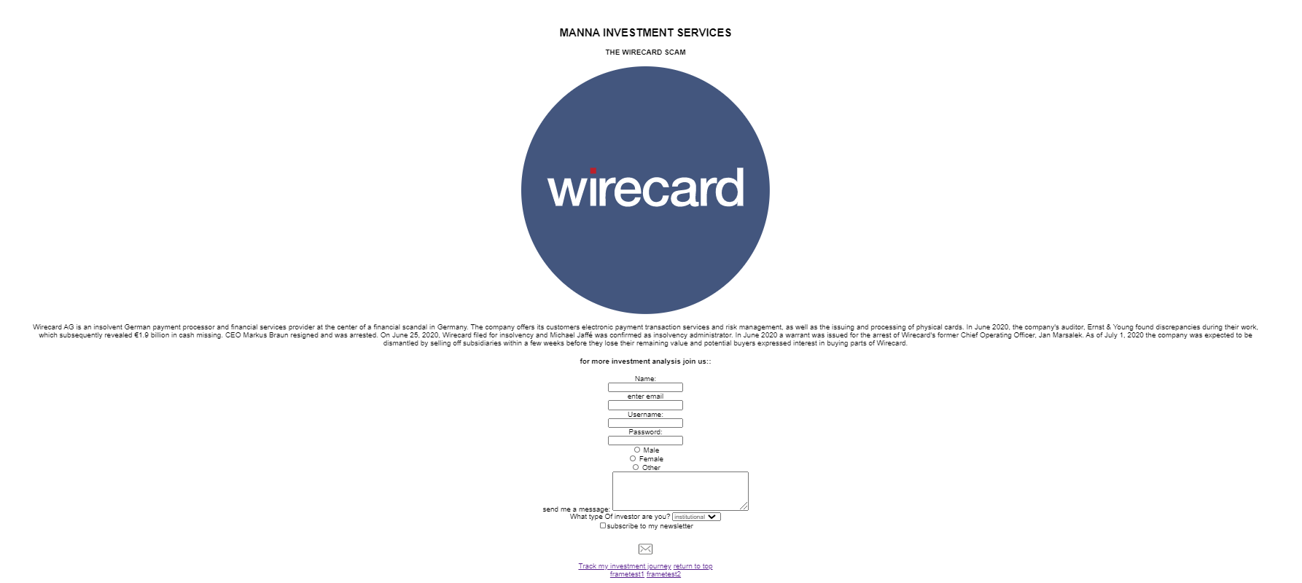

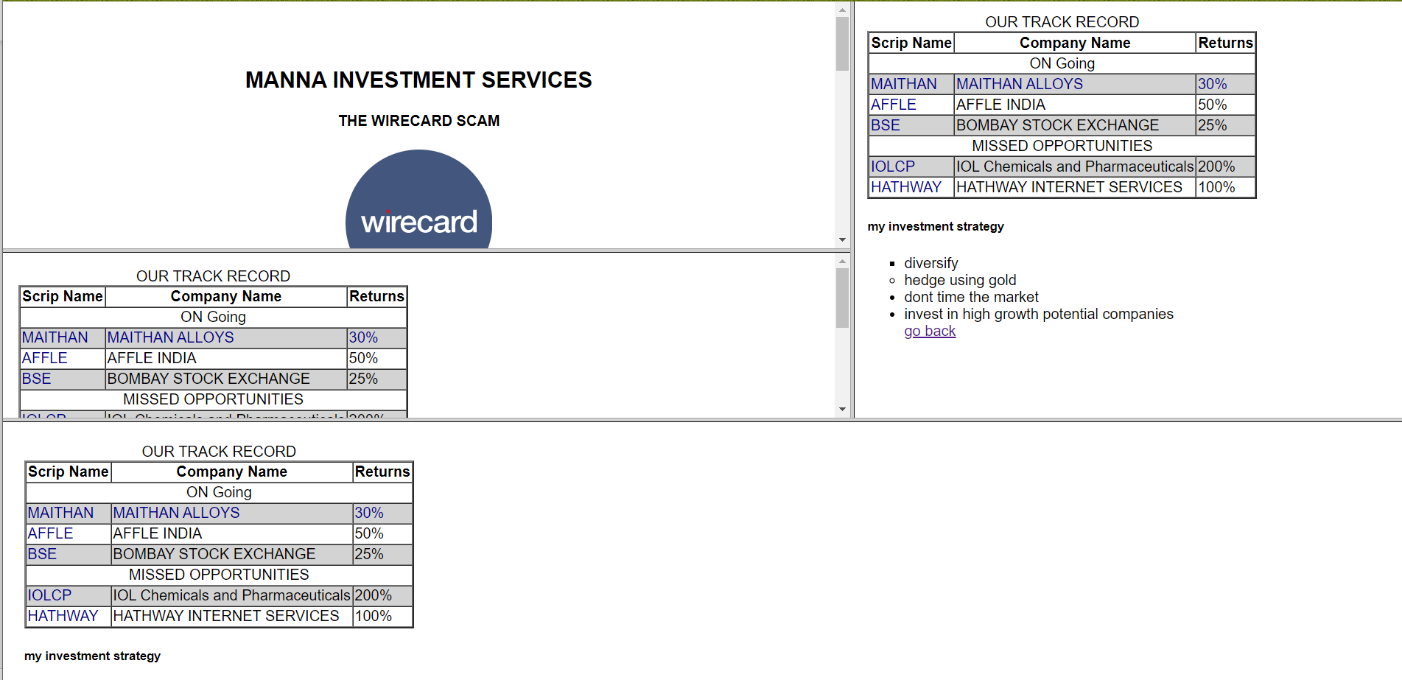

**B.3. Observations and Learning**

Framesets are deprecated and shouldn’t be used

Tables are good representation of info

A links and v links are well uselful

**B.4. Conclusion**

1. Understood the basic Technique in building a static web application using HTML

2. Implemented basic tags of HTML with attributes

3. Understood usage of basic editor like Sublime Text 2 or 3

4. Used table formatting